caXchange Hub

caXchange – ScenPro, Inc.
Ekagra

Technical Architecture Guide
DOCUMENT CHANGE HISTORY
Version Number | Date | Contributor | Description
V1.0 | 2/19/2007 | M. Medirratta  C. Griffin  W. Ver Hoef | New Document
1.1 | 1/11/2008 | Michael Holck | Updated to new template and removed non hub content

Updated January 25, 2008January 15, 2008

TABLE OF CONTENTS
1 Introduction 4
1.1 Chapter Organization and Content 4
1.2 Overview of the Guide 4
1.3 Organization of the Guide 4
1.4 Intended Audience for the Guide 5
1.5 Scope of the Guide 5
1.6 Document Text Conventions 5
1.7 Related documents 6
2 Overview of the Software 8
2.1 Chapter Organization and Content 8
2.2 Software Overview 8
2.2.1 Project Background 8
2.2.2 System Overview 8
2.2.3 Features of the caXchange Hub Software Solution 9
2.3 System Requirements 9
3 caXchange Installation 11
4 caXchange Requirements 12
4.1 Chapter Organization and Content 12
4.2 Summary of caXchange Requirements 12
5 caXchange Architecture 15
5.1 Chapter Organization and Content 15
5.2 System Architecture Overview 15
5.3 Architectural Design 20
caXchange Design 21
5.4 Chapter Organization and Content 21
5.5 caXchange 21
5.5.1 Use Case 21
5.5.2 Logical Design 23
5.5.2.1 caXchange Grid Service 23
5.5.2.2 caXchangeResponse Listener 23
5.5.2.3 caXchange Service Assembly 24
5.5.2.4 Sequence Diagrams 25
5.5.2.5 Security Services – Authentication/Authorization 27
5.5.2.6 Workflow Service 29
5.5.2.7 caAdapter Transformation Service 30
5.5.2.8 C3PR Data Service 31
5.5.2.9 Audit Service 31
5.5.2.10 CTOM WebService Client 32
5.5.3 Sequence Diagrams 32
5.5.4 Deployment Diagrams 34
5.6 Technology Stack 36
6 Security and Security Management 37
6.1 Chapter Organization and Content 37
6.2 Software Authorization 37
6.3 Configuring Software Authorizations 39
7 Grid and Web Services 40
7.1 Chapter Organization and Content 40
7.2 caXchange Routing and Workflow Web Service 40
7.3 Technical Manuals/Articles 44
7.4 caBIG Material 44
7.5 caCORE Material 44

Introduction
The caXchange Hub is the enterprise service hub for exchanging clinical trial information between applications and systems. The caXchange Hub (originally Lab Information Hub) is now a more generic platform for exchanging all types of clinical trial data and messages using service invocations and data exchange and is leveraged in the CCTS project.
This Technical Architecture Guide provides the software architecture and high level design for the caXchange Hub. This document is used as a recommendation and guideline by the development team to develop a detailed design for the system. It emphasizes the architecturally significant parts of the design model.

Chapter Organization and Content
The purpose of this chapter is to provide a high level overview of the caXchange hub solution, its components and the overall content of this guide.
Topics in this chapter include:
- Overview of the Guide
- Organization of the Guide

- Scope of the Guide
- Document Text Conventions
- Related documents

Overview of the Guide
This guide introduces the technical and architectural aspects of the caXchange Hub Version 1.0. It provides an overview of the architecture, describes the components and their use cases, identifies the technology stack and provides some technical reference.

Organization of the Guide
This table provides a summary of the focus of each chapter.
Table 1 - Main Contents of the caXchange Technical Architecture Guide
Chapter in caXchange Technical Architecture Guide | Chapter Contents
Chapter 1 | Error: Reference source not found
Chapter 2 | Error: Reference source not found
Chapter 3 | Error: Reference source not found
Chapter 4 | Error: Reference source not found
Chapter 5 | Error: Reference source not found
Chapter 6 | Error: Reference source not found
Chapter 7 | Error: Reference source not found
Chapter 8 | Error: Reference source not found
Chapter 9 | Error: Reference source not found
Chapter 10 | Error: Reference source not found
Appendix A | References
Appendix B | Glossary
Index | Error: Reference source not found

Intended Audience for the Guide
The intended audience for this document includes developers and architects interested in obtaining an overview of the architecture and high level design for the caXchange Hub.

Scope of the Guide
The scope of this document is limited to the requirements as identified in the 1.0 version release of the caXchange solution. For additional project and requirement-specific information, please refer to the following documents:
- caXchange Software Requirements Specification (SRS)
- caXchange Use Case Specification and Realization Document
The latest versions of these documents can be found in:
https://gforge.nci.nih.gov/plugins/scmcvs/cvsweb.php/caxchange/Deliverables/?cvsroot=caxchange

Document Text Conventions
The following table shows various typefaces to differentiate between regular text and menu commands, keyboard keys, and text that you type. This illustrates how conventions are represented in this guide.
Table 2 - Document Conventions
Convention | Description | Example
Bold & Capitalized Command  Capitalized command > Capitalized command | Indicates a Menu command  Indicates Sequential Menu commands | Admin > Refresh
text in small caps | Keyboard key that you press | Press enter
text in small caps + text in small caps | Keyboard keys that you press simultaneously | Press shift + ctrl and then release both.
Special typestyle | Used for filenames, directory names, commands, file listings, source code examples and anything that would appear in a Java program, such as methods, variables, and classes. | URL_definition ::= url_string
Boldface type | Options that you select in dialog boxes or drop-down menus. Buttons or icons that you click. | In the Open dialog box, select the file and click the Open button.
Italics | Used to reference other documents, sections, figures, and tables. | caCORE Software Development Kit 1.0 Programmer’s Guide
Italic boldface type | Text that you type | In the New Subset text box, enter Proprietary Proteins.
Note: | Highlights a concept of particular interest | Note: This concept is used throughout the installation manual.
Warning! | Highlights information of which you should be particularly aware. | Warning! Deleting an object will permanently delete it from the database.
{} | Curly brackets are used for replaceable items. | Replace {root directory} with its proper value such as c:\cabio

Related documents
For additional project information, please refer to the following documents:
- caXchange Software Requirements Specification (SRS)
- caXchange Use Case Specification and Realization Document
- caXchange Design Document
- caXchange Installation Guide
- caXchange Administration Guide
The latest versions of these documents can be found in:
https://gforge.nci.nih.gov/plugins/scmcvs/cvsweb.php/caxchange/Deliverables/?cvsroot=caxchange

Overview of the Software

Chapter Organization and Content
Topics in this chapter include:
- Project Background
- System Overview
- Features of the caXchange Hub Software Solution
- System Requirements

Software Overview

Project Background
The CCTS suite of applications needs to be able to exchange information between all applications in an audited and controlled manner. The caXchange hub provides this capability by using standard service hub protocols and messaging formats to receive, route, log, and send messages and data between applications. This can also be used to send and receive clinical trial lab information as was done in the original lab information hub effort.
This project focuses on the development of an open-source, caBIG™ compatible solution to support the exchange of data collected during a clinical trial. The resulting solution is intended to be stand-alone and caBIG Silver-level compatible.

System Overview
The overall goal of this project is to build a hub system that can be adapted and extended to multiple data formats and whose value and usability can be pilot-tested in one or more cancer centers. As the caBIG program is the primary sponsor, all work performed for this project must be done in compliance with the caBIG principles of open source, open development, open access, and federation. Software that is used and/or developed in the context of this project must be caBIG™ compatible at the silver level (https://cabig.nci.nih.gov/guidelines_documentation/caBIGCompatGuideRev2_final.pdf) and be made available to the community through resources provided by the General Contractor.
The key roles in the project are defined in the following table.
Table 3 - Key Roles in the caXchange Project
Role | Name | Comments
Project Sponsor | caBIG
Reviewer | caBIG Architecture Workspace | Will review and provide guidance of architecture artifacts
Reviewer | caBIG Lab SIG | Will provide requirements feedback
User | NCICB | Responsible for hosting the caXchange
caBIG Adopter/User | Georgetown University, Lombardi Cancer Center | Responsible for sending patient lab data to the caXchange
Developer | Scenpro, Ekagra Software Technologies | Joint development team

Features of the caXchange Hub Software Solution
Key features of the caXchange solution include the following:
- Service oriented flexible and extensible architecture
- Utilizes open source ESB technology – Logic Blaze Fuse
- Reusable services built to the Java Business Integration (JBI) specification that can be deployed to any JBI container
- Supports message routing and customized workflows
- Supports user authentication and authorization
- Supports data transformation service via caAdapter and converts laboratory data into HL7 v3 messages
- Provides a Log Locator Tool to view the message exchange status

System Requirements
The following table provides a very high-level summary of the requirements of the caXchange system:
Table 4 - High Level Summary of Requirements
Requirement ID | Requirement Description
1.0 | Provide the ability to receive, transform, and route patient lab data into a HL7v3 CT Laboratory Observation Periodic Report format to various external systems.
2.0 | Provide the ability for Cancer Centers to send patient laboratory data to the LIH. The patient lab data will be in a caAdapter required .csv format. The solution should not require the Cancer Center to perform any elaborate programming.
3.0 | Provide the ability to receive the HL7 v3 CT Laboratory Observation Periodic Report message from a service external to the LIH and persist the contained domain data in the payload into the CTOM database.
4.0 | Provide the ability to monitor the LIH activities and perform administrative functions on the LIH

A more in-depth summary of the system requirements is presented in Chapter 4 caXchange Requirements. Alternatively, a more detailed understanding of the requirements can be found in the requirements document: Laboratory Information Integration Hub Project Software Requirements Specification. The URL to this document is:
https://gforge.nci.nih.gov/plugins/scmcvs/cvsweb.php/labhub/Deliverables/Lab%20Hub%20Software%20Requirements%20Specification%20Final%20Task%202.3.2.1.doc?cvsroot=labhub

caXchange Installation
A separate document, the caXchange Version 1.0 Installation Guide, outlines the steps for installing and configuring the various components that comprise the caXchange version 1.0 solution. Please refer to that document for details. The latest version of this document can be found in
https://gforge.nci.nih.gov/plugins/scmcvs/cvsweb.php/caxchange/Deliverables/?cvsroot=caxchange

caXchange Requirements

Chapter Organization and Content
This chapter includes:
- Summary of caXchange Requirements on this page

Summary of caXchange Requirements
This section summarizes the requirements documented in the Laboratory Information Integration Hub Project Software Requirements Specification document
(https://gforge.nci.nih.gov/plugins/scmcvs/cvsweb.php/labhub/Deliverables/Lab%20Hub%20Software%20Requirements%20Specification%20Final%20Task%202.3.2.1.doc?cvsroot=labhub).
Table 5 - Summary of Detailed Requirements
Requirement ID | Requirement Description
1.0 | Provide the ability to receive, transform, and route patient lab data into a HL7v3 CT Laboratory Observation Periodic Report format to various external systems.
1.1 | The sender of each message to the LIH must be authenticated to ensure the system is a known user to the LIH
1.2 | A check must be performed to ensure that the sender of each message is authorized to perform a defined workflow on the LIH.
1.3 | An Acknowledgement Response must be returned to the sender indicating the message was successfully received.  An successful audit message will be logged.
1.4 | If an error occurred or user authentication or authorization failed, then an Error Response must be returned to the sender indicating the reason why the request failed.  In case of failure, an error audit message will be logged.
1.5 | After a message is received, the message is normalized and routed to the appropriate service on the LIH. The routing is done based on metadata in the received message.
1.6 | Provide the ability for the Cancer Center Hub Client to specify a workflow that should be executed by the LIH for a message
1.7 | Provide the ability to route an incoming message from the Cancer Center Hub client to the Transformation Service.
1.8 | Provide the ability to route the output of the Transformation Service to the CTOM Service
1.9 | Provide the ability to guarantee message delivery to services on the LIH even in the event of a server shut down
1.10 | Provide the ability to a developer to define routing of a message on the hub without writing new code.
1.11 | The system must support the concept of a normalized message. A normalized message meaning a common message interface or construct that the LIH can route to services deployed on the LIH.
1.12 | Provide the ability to allow the sender to specify other HL7 and non-HL7 input message formats without programming (only caAdapter required .csv will be transformed into the v3 CT Lab message)
1.13 | Provide the ability to transform patient laboratory data in a caAdapter specified .csv format to an HL7v3 CT Laboratory Observation Periodic Report message
1.14 | Audit the occurrence of invalid messages from the transformation service to a audit/log data store.
1.15 | Audit a summary of the transformation process. The audit should provide a count of records that were processed successfully and unsuccessfully. The audits should list the MRN’s of the records that were processed successfully and unsuccessfully.
1.16 | Provide a user interface to readily map an input lab’s incoming .csv message format to the HL7v3 CT Laboratory Observation Periodic Report message format.
1.17 | Provide the ability to retrieve data concerning Studies and Investigators from the C3PR system deployed at the Lombardi Cancer Center utilizing the C3PR caCORE query APIs. This data will then be added to the HL7v3 message instance(s)
1.18 | If a patient belongs to multiple trials the system will create a HL7v3 message instance for each trial. The lab data will eventually be persisted for every trial the patient belongs to.
1.19 | Provide the ability to view the audit/log data repository for audits and logs in a specified period of time
1.20 | Each Cancer Center should only be able to view their respective audits/logs.
1.21 | Provide a service (Audit/Log Service) on the LIH that has the responsibility for receiving messages (Audit Messages) from any other service on the LIH containing audit/log data in a common format.
1.22 | The Audit/Log Service will persist the audit/log data received in the message in a common audit /log data store.
1.23 | If the Audit/Log Service receives a message with a “fatal” alert level, the service will notify the Hub Administrator or other support personnel of the fatal conditions via e-mail
2.0 | Provide the ability for Cancer Centers to send patient laboratory data to the LIH. The patient lab data will be in a caAdapter required .csv format. The solution should not require the Cancer Center to perform any elaborate programming.
2.1 | Minimize the local development work to send laboratory data to the CAXCHANGE HUB
2.2 | The CCHC must be able to retrieve laboratory data in a specified format and create a message that can be sent to the CAXCHANGE HUB. This message must contain the appropriate metadata for security, routing, and transformation on the CAXCHANGE HUB
2.3 | The CCHC will retrieve files containing the laboratory data in a .csv format from a specified directory on a server at Lombardi Cancer Center
2.4 | The CCHC will poll a specified directory repeatedly for a laboratory data file with a user specified amount of time between each polling
2.5 | After a particular laboratory file is sent to the CAXCHANGE HUB the file should be deleted, renamed, or moved so it will not be resent to the CAXCHANGE HUB.
2.6 | The CCHC must be able to send the laboratory data message to the CAXCHANGE HUB
2.7 | The CCHC must be able to log successful and unsuccessful attempts to send messages to the CAXCHANGE HUB
2.8 | Security will be placed on the directory that the CCHC will poll for the .csv files. The security will allow only authorized users to put .csv files in the directory.
2.9 | Develop an utility or scripts that will process the client lab data files and convert them into caAdapter required .csv files.
3.0 | Provide the ability to receive the HL7 v3 CT Laboratory Observation Periodic Report message from a service external to the LIH and persist the contained domain data in the payload into the CTOM database.
3.1 | The CTOM Data Service must receive messages in the HL7v3 CT Laboratory Observation Periodic Report format
3.2 | The CTOM Data Service must perform authentication and authorization security checks to ensure the sender is a recognized client and is authorized to send data to the CTOM data service
3.3 | The CTOM Data Service must persist the data from HL7v3 CT Laboratory Observation Periodic Report message to the CTOM database
3.4 | The CTOM Data Service will parse the HL7 v3 CT Laboratory Observation Periodic Report messages and persist only the domain related data into the CTOM database
4.0 | Provide the ability to monitor the LIH activities and perform administrative functions on the LIH
4.1 | The LIH must provide the ability to deploy new services on the LIH without disrupting processing of existing services and messages
4.2 | The LIH must provide the ability to uninstall new services on the LIH without disrupting processing of existing services and messages
4.3 | The LIH must provide the LIH Administrator the ability to shutdown the LIH
4. 4 | The LIH Administrator must be given the capability to add new users (LIH Clients) and configure authorization of services on the LIH
4.5 | The LIH Administrator must be given the opportunity to view LIH performance via a GUI console
4.6 | The LIH Administrator must be given the ability to see if services on the LIH are installed, uninstalled, or running.
4.7 | The LIH Administrator must be given the ability to view the number of messages a service on the LIH has received.
4.8 | The LIH Administrator must be given the ability to view the number of messages a service on the LIH has sent out
4.9 | The LIH Administrator must be given the ability to view the number of inbound messages a service receives per second.

Please refer to the requirements document identified above for a more detailed understanding of these requirements.

caXchange Architecture

Chapter Organization and Content
Topics in this chapter include:
- System Architecture Overview on this page
- Architectural Design on page 24

System Architecture Overview

caXchange provides the ability to route data from multiple originating systems to various destinations. The destinations to which data will be routed may accept data in various formats.

Figure 5-1 diagram shows a high-level view of the flow of data that will take place in caXchange1.0. As shown, caXchange will receive requests from different sources and will route them to various targets based on the type request.
Figure 5-2 shows a more detailed view of the overall solution as well as numbering showing the sequence in which activities are performed.
CTODS DB
1
1
1
1
2
2
2
2
3
HL7 V3
3
4
5
5
CSV
caXchange
(ESB)
C3PR
C3D
caAERS
CCHC
Lab
System
PSC
CTODS
Database
CTODS
Lab Viewer
Study Creation Message (BRIDG based)
Register Subject Message (BRIDG based)
CT Lab Message (HL7 V3)
Load Lab in CDMS Message (BRIDG based)
Schedule Modification Message (BRIDG based)
4 Lab Data
2.1
(Patient Position)
2
2.1
(Patient Position)
Figure 1 - caXchange 1.0 High Level Data Flow

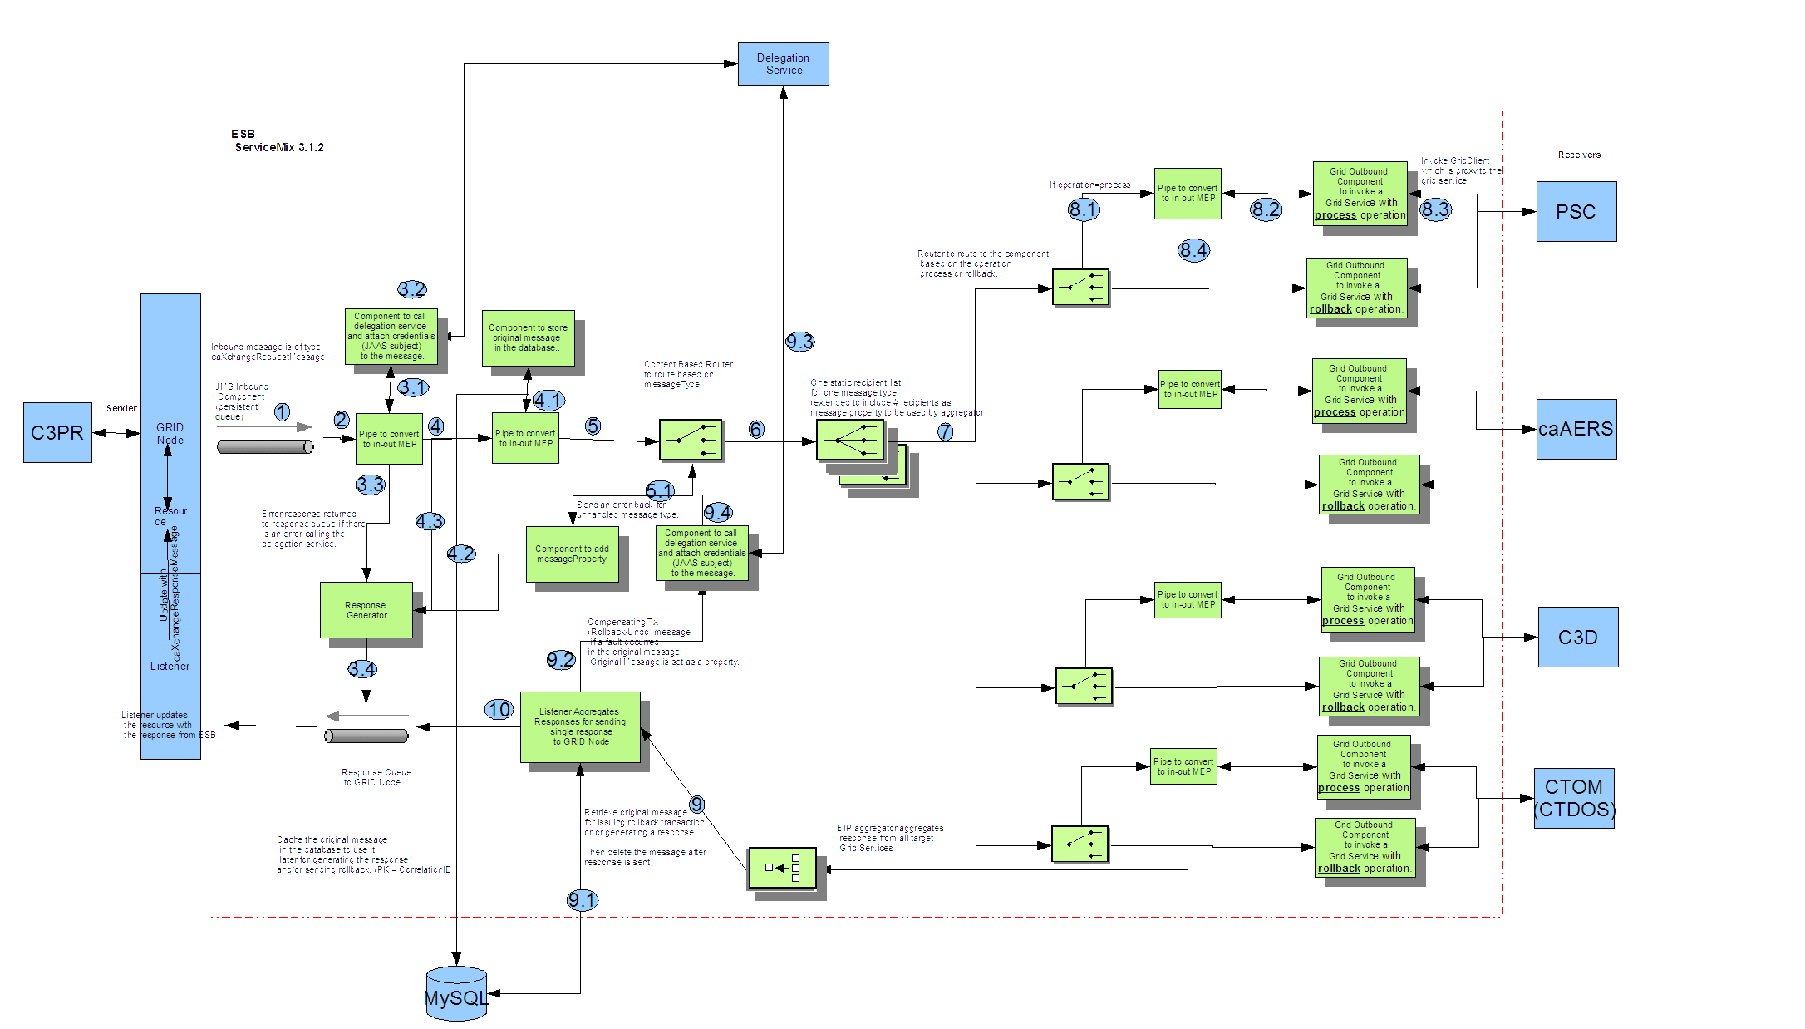
Figure 2 - Detailed Design and Workflow

Architectural Design
caXchange uses Apache ServiceMix open source enterprise service bus (ESB). Services and components have been written and deployed on the ESB to provide routing and transformation services.
The following diagram depicts the high level components in caXchange:

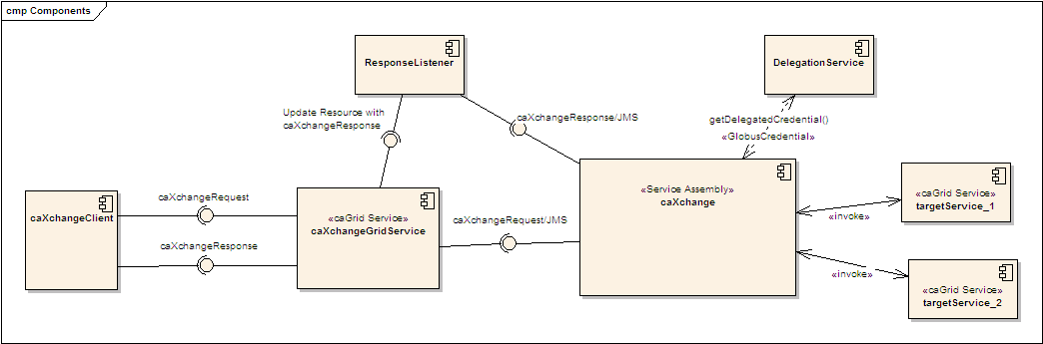
Figure 3 - caXchange 1.0 Component Diagram
A caXchange client sends a caXchangeRequest message to caXchangeGridService.
caXchangeGridService is a caGrid service which acts as a proxy for the caXchange service assembly deployed on Servicemix JBI(Java Business Integration) Container.
caXchangeGridService creates a WS-Resourceframework Resource associated with the caXchangeRequest. This caXchangeRequest is then forwarded to the caXchange service assembly for processing. This is done by pushing caXchangeRequest message to the jms inbound component of caXchange service assembly.
caXchange service assembly then invokes the DelegationService for the authorization credentials before routing the request message based on the message type. Please refer to the caXchange detailed design diagram for routing details.
Outbound components then invoke the target services.
Responses from the target services are then aggregated into a caXchangeResponse message.

caXchange Design

Chapter Organization and Content
Topics in this chapter include:
- caXchange
- Technology Stack on page 49

caXchange
The caXchange is defined as the software component that is primarily responsible for receiving input from various external systems, routing the input to various services that are hosted on the grid, and eventually routing the output of those services to external systems. The caXchange is based on Apache ServiceMix which is an Enterprise Service Bus (ESB) built to the Java Business Integration (JBI) specification.

Use Case
The following diagram shows the use cases and actors. For more details on the use cases, please refer to the caXchange Enterprise Architect Use Case Model ( PUT USE-CASES.ZIP LINK HERE).

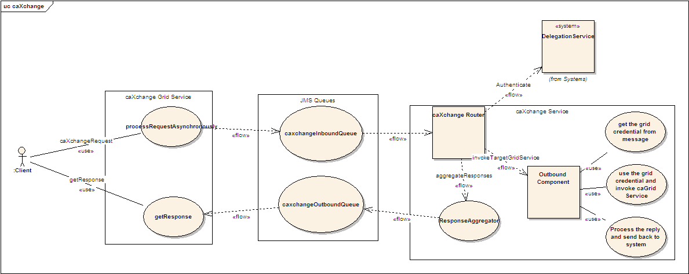

Figure 4 - caXchange Use Case

Logical Design

caXchange Grid Service
caXchange grid service acts as a proxy for caXchange. It forwards incoming requests to caXchange for processing. To keep track of a request it creates a WS-Resource framework resource. The grid service then returns an EndPointReference to the client. The client uses this end point reference to invoke the getResponse operation. The grid service also creates a response listener, which listens for caXchangeResponse and updates the resource. Please see the caXchange interface specification document for details of the operations it exposes.
Operations
Method | Notes | Parameters | Return
ProcessRequestAsynchronously | Process a caXchangeRequest | CaXchangeRequest | CaXchangeContextReference
getResponse | Gets the caXchangeResponse if it is ready, otherwise throws an Exception | None | caXchangeResponse

      - caXchangeResponse Listener
The caXchangeResponse listener lives with the caXchange Grid service. It listens for the response on the jms queue associated with the response outbound component of the caXchange service assembly. Once a response is received from the queue, the resource associated with the corresponding request is updated. The client can then use the getResponse method to get the caXchangeResponse.
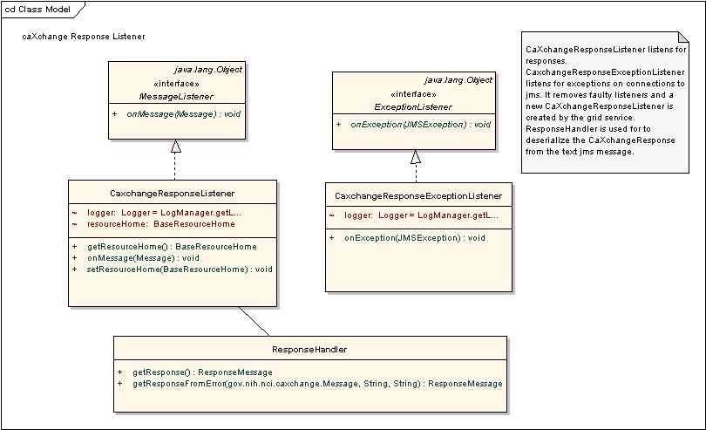
Figure 5 - caXchange ResponseListener Class Model

caXchange Service Assembly
caXchange service assembly is deployed on the Servicemix JBI container. The caXchange design diagram (Fig 5.2) gives the detailed design of the caXchange service assembly.
The following table describes caXchange service assembly component. Numbers in the component column refer to the number in the caXchange design diagram given to an exchange going into that component.
Component | Type | Purpose
1. InboundComponent | JMS | Receive inbound caXchangeRequest messages.
3. Invoke Delegation Service | Bean/EIP (Enterprise Integration Patterns) | This includes a pipeline, which invokes a bean component that calls delegation service for authentication and attaches the credentials (JAAS subject) to the message.
3.3/4.3 Response Generator | Bean | Generates an error response.
4.Save Message | Bean/EIP | This includes two components, a pipeline, which invokes a bean component that saves the message to a database. The saved message is used to contruct a response and/or sends a rollback.
5. Content Based Router | EIP | Routes the message based on the message type to a particular static recipient list.
6. Static Recipient List | EIP Customized | Sends the message to multiple recipients for invoking target services. This is customized to add a message property for number of recipients. This is used to aggregate responses
7. Content Based Router | EIP | Routes message based on operation. If the operation is process the message is routed to a pipeline to invoke the service and get a response as an in-out message exchange. If the operation is rollback the message is send without expecting a response as an in-only message exchange.
8.1 Pipeline | EIP | Pipeline to invoke target service as an in-out message exchange.
8.2 Outbound Component | Bean | Outbound component that invokes the target Grid Service.
8.4 Aggregator | EIP Customized | Aggregator component aggregates responses from multiple target services. This is customized to work with the customized static recipient list in #6 above.
9 Aggregator Listener | Bean | Aggregated responses from the aggregator are forwarded to this component, which does two things.  - It looks at the response and the message type to verify if a rollback is required. If required a message with the rollback is sent to the content based router #5 after authentication and authorization by #3.  - It creates a caXchangeResponse and sends it to the jms outbound binding component.
10.ResponseComponent | JMS | Outbound caXchangeResponse are pushed to this component.

Authentication/Authorization

Delegation Services
caXchange uses the DelegationService lookup for authorization.
- Each caXchangeRequest comes with an End Point Reference (EPR) pointing to its credentials.
- caXchange then invokes DelegationService using the EPR
- The DelegationService return back the userCredentials (JAAS Subject) in the EPR is valid.
- Attaches the JAAS Subject to the message
- The outbound component then retrieves the JAAS Subject and uses it to invoke the target grid services.

CSM Authentication Manager
CSM is used only for Log Locator Tool (LLT) and not directly by caXchange. The CSM AuthenticationManager is an interface that authenticates a user against a credential provider. The AuthenticationManager contains several methods, details of which can be found in caCORE3.1_Tech_Guide (chapter 9 – CSM Module). For the current scope of the caXchange implementation, the private boolean login (SenderID, Password) method from this interface is used.

CSM AuthorizationManager
CSM is used only for Log Locator Tool (LLT) and not directly by caXchange. The CSM AuthorizationManager is an interface that authorizes a user and its desired operation against an authorization schema. The AuthorizationManager contains several methods, details of which can be found in caCORE3.1_Tech_Guide (chapter 9 – CSM Module). For the current scope of the caXchange implementation, the method used is private boolean checkPermission(senderID, serviceId, desiredOperation) from this interface.

Audit Service
The Audit Service is implemented following JBI specifications on the caXchange. This service will perform the following:
- Receives notification on each MessageExchange.
- Check whether it needs to audit for that message.
- Extract the audit information and sends it to Common Logging Module (CLM) for auditing.
- CLM stores it in database.

- The CLM API takes these messages from the database and displays on the Log Locator Tool
- Users on LLT can see messages only for the organization for which they are authorized. Also the users can view messages based on the session ID which is linked to the file name (along with a date/time stamp) sent in by the external clients.

Configuration Items
The database location, target grid-services url’s and JMS Queue locations are configurable items and are stored as properties in the conf/caxchange.properties file.

Sequence Diagrams

Successful Flow Sequence Diagram
Sequence for a successful flow through caXchange is depicted below. Detailed flow through the caXchange service assembly is depicted in the caXchange design diagram.
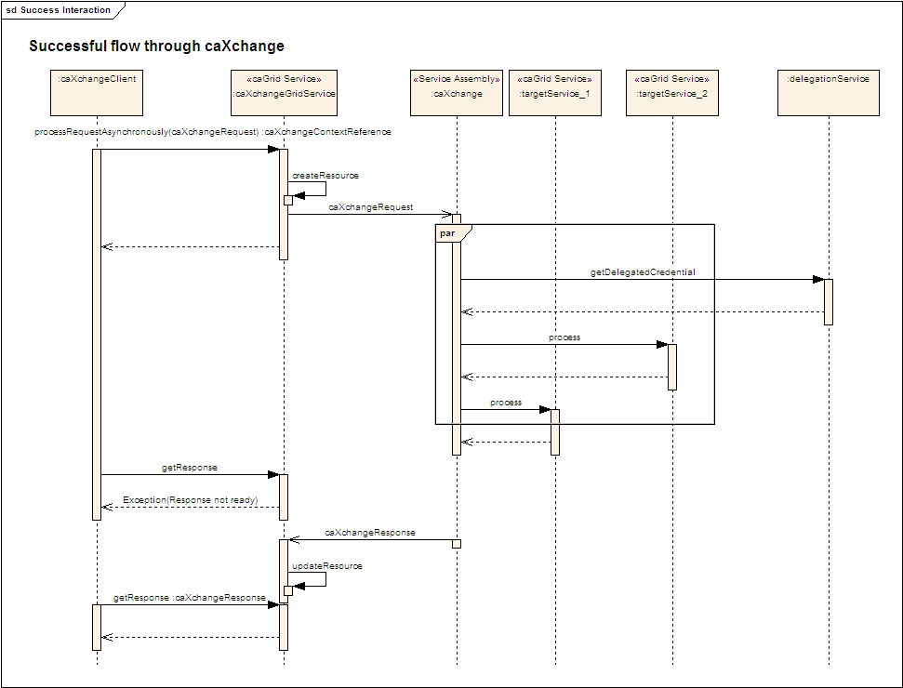
Figure 6 - caXchange Successful Flow sequence diagram

Rollback Flow Sequence Diagram
Sequence for a rollback interaction with caXchange is depicted below. Detailed interaction within caXchange service assembly is depicted in the caXchange design diagram.
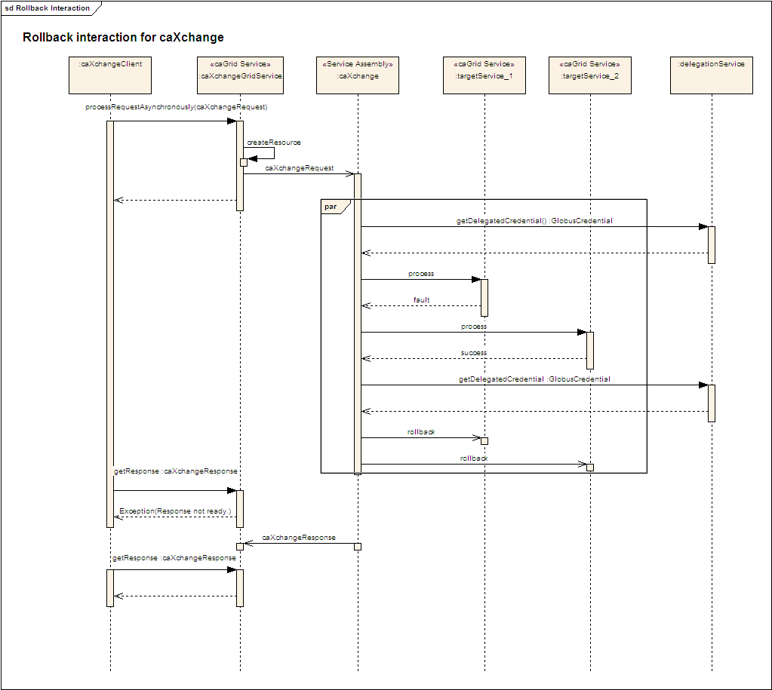
Figure 7 - caXchange: Rollback Sequence Diagram

Deployment Diagrams
The following depicts the deployment diagram for caXchange components.
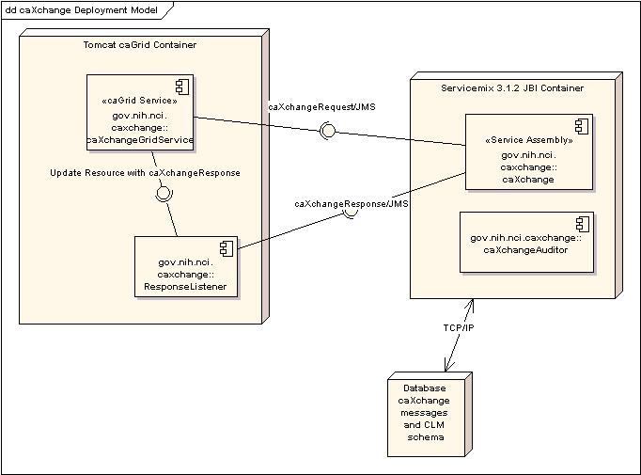
Figure 8 - caXchange Deployment Diagram

Technology Stack
The following technologies are used in the caXchange solution or in the development of the solution:
- JDK 1.5.0
- Apache ServiceMix
- MySQL

- Apache Tomcat
- Enterprise Architect 4.5+
Extensive instructions on the installation and configuring of the core software components used in the caXchange solution are covered in the caXchange Version 1.0 Installation Guide (located along with all the other caXchange project deliverables at https://gforge.nci.nih.gov/plugins/scmcvs/cvsweb.php/caxchange/Deliverables/?cvsroot=caxchange).

Grid Services

Chapter Organization and Content
Topics covered in this chapter include:
- caXchange grid-Service on this page

  - caXchange grid-Service
caXchange gridservice acts as a proxy to service-assembly. Clients can send caXchangeRequest via HTTPS to gridservice which pushes them into a JMS queue. Service-assembly then picks it up from there. Following is the schema for caXchangeRequest
<?xml version="1.0" encoding="UTF-8"?>
<xs:schema xmlns:xs="http://www.w3.org/2001/XMLSchema" xmlns:caXchange="http://caXchange.nci.nih.gov/messaging" targetNamespace="http://caXchange.nci.nih.gov/messaging" elementFormDefault="qualified" attributeFormDefault="unqualified">
<xs:element name="caXchangeRequestMessage" type="caXchange:message"/>
<xs:element name="caXchangeResponseMessage" type="caXchange:responseMessage"/>
<xs:complexType name="message">
<xs:sequence>
<xs:element name="metadata" type="caXchange:metadata"/>
<xs:element name="request" type="caXchange:request"/>
</xs:sequence>
</xs:complexType>
<xs:complexType name="responseMessage">
<xs:sequence>
<xs:element name="responseMetadata" type="caXchange:responseMetadata"/>
<xs:element name="response" type="caXchange:response"/>
</xs:sequence>
</xs:complexType>
<xs:complexType name="request">
<xs:sequence>
<xs:element name="businessMessagePayload" type="caXchange:messagePayload"/>
</xs:sequence>
</xs:complexType>
<xs:complexType name="response">
<xs:sequence>
<xs:element name="responseStatus" type="caXchange:statuses"/>
<xs:choice>
<xs:element name="caXchangeError" type="caXchange:errorDetails" />
<xs:element name="targetResponse" type="caXchange:targetResponseMessage" maxOccurs="unbounded"/>
</xs:choice>
</xs:sequence>
</xs:complexType>
<xs:complexType name="metadata">
<xs:sequence>
<xs:element name="operation" type="caXchange:operations"/>
<xs:element name="messageType" type="caXchange:messageTypes"/>
<xs:element name="externalIdentifier" type="xs:string"/>
<xs:element name="caXchangeIdentifier" type="xs:string" minOccurs="0">
<xs:annotation>
<xs:documentation>Populated by caXchange components, any value provided by the client will be overridden by the caXchange components</xs:documentation>
</xs:annotation>
</xs:element>
<xs:element name="credentials" type="caXchange:credentials" minOccurs="0"/>
</xs:sequence>
</xs:complexType>
<xs:complexType name="responseMetadata">
<xs:sequence>
<xs:element name="externalIdentifier" type="xs:string"/>
<xs:element name="caXchangeIdentifier" type="xs:string">
<xs:annotation>
<xs:documentation>Populated by caXchange components, any value provided by the client will be overridden by the caXchange components</xs:documentation>
</xs:annotation>
</xs:element>
</xs:sequence>
</xs:complexType>
<xs:complexType name="credentials">
<xs:sequence>
<xs:choice>
<xs:element name="userName" type="xs:string"/>
<xs:element name="groupName" type="xs:string"/>
<xs:element name="gridIdentifier" type="xs:string"/>
</xs:choice>
<xs:element name="password" type="xs:string" minOccurs="0"/>
<xs:element name="delegatedCredentialReference" type="xs:string" minOccurs="0"/>
</xs:sequence>
</xs:complexType>
<xs:complexType name="targetResponseMessage">
<xs:sequence>
<xs:element name="targetServiceIdentifier" type="xs:string"/>
<xs:element name="targetServiceOperation" type="xs:string"/>
<xs:element name="targetMessageStatus" type="caXchange:messageStatuses"/>
<xs:choice>
<xs:element name="targetError" type="caXchange:errorDetails"/>
<xs:element name="targetBusinessMessage" type="caXchange:messagePayload"/>
</xs:choice>
</xs:sequence>
</xs:complexType>
<xs:complexType name="messagePayload">
<xs:sequence>
<xs:element name="xmlSchemaDefinition" type="xs:anyURI"/>
<xs:any processContents="lax" minOccurs="0" maxOccurs="1" />
</xs:sequence>
</xs:complexType>
<xs:complexType name="errorDetails">
<xs:sequence>
<xs:element name="errorCode" type="caXchange:errorCodes"/>
<xs:element name="errorDescription" type="xs:string"/>
</xs:sequence>
</xs:complexType>
<xs:simpleType name="errorCodes">
<xs:annotation>
<xs:documentation>
000 OK
001 Unknown
101 AxisFault from the endpoint
201 Malformed URI
202 RemoteException
203 ConnectException
204 Timeout
301 TransformerException
302 DeserializationException
303 SAX Exception
304 Paser Configuration Exception
305 IO Exception
</xs:documentation>
</xs:annotation>
<xs:restriction base="xs:string"/>
</xs:simpleType>
<xs:simpleType name="messageStatuses">
<xs:restriction base="xs:string">
<xs:enumeration value="RESPONSE"/>
<xs:enumeration value="ERROR"/>
<xs:enumeration value="FAULT"/>
</xs:restriction>
</xs:simpleType>
<xs:simpleType name="statuses">
<xs:restriction base="xs:string">
<xs:enumeration value="SUCCESS"/>
<xs:enumeration value="FAILURE"/>
</xs:restriction>
</xs:simpleType>
<xs:simpleType name="operations">
<xs:restriction base="xs:string">
<xs:enumeration value="PROCESS"/>
<xs:enumeration value="COMMIT"/>
<xs:enumeration value="ROLLBACK"/>
</xs:restriction>
</xs:simpleType>
<xs:simpleType name="messageTypes">
<xs:restriction base="xs:string">
<xs:enumeration value="STUDY_CREATION"/>
<xs:enumeration value="REGISTER_SUBJECT"/>
<xs:enumeration value="CT_LAB_DATA"/>
<xs:enumeration value="LOAD_LAB_TO_CDMS"/>
<xs:enumeration value="LAB_BASED_AE"/>
<xs:enumeration value="SCHEDULE_MODIFICATION"/>
</xs:restriction>
</xs:simpleType>
</xs:schema>

Appendix A References

Technical Manuals/Articles
- National Cancer Institute. “caCORE SDK 3.2 Programmers Guide”,
- http://ncicb.nci.nih.gov/infrastructure/cacoresdk
- Java Bean Specification: http://java.sun.com/products/javabeans/docs/spec.html
- Foundations of Object-Relational Mapping: http://www.chimu.com/publications/objectRelational/
- Object-Relational Mapping articles and products: http://www.service-architecture.com/object-relational-mapping/
- Hibernate Reference Documentation: http://www.hibernate.org/hib_docs/reference/en/html/
- Basic O/R Mapping: http://www.hibernate.org/hib_docs/reference/en/html/mapping.html
- Java Programming: http://java.sun.com/learning/new2java/index.html
- Javadoc tool: http://java.sun.com/j2se/javadoc/
- Junit: http://junit.sourceforge.net/
- Extensible Markup Language: http://www.w3.org/TR/REC-xml/
- XML Metadata Interchange: http://www.omg.org/technology/documents/formal/xmi.htm

caBIG Material
- caBIG: http://cabig.nci.nih.gov/
- caBIG Compatibility Guidelines: http://cabig.nci.nih.gov/guidelines_documentation

caCORE Material
- caCORE: http://ncicb.nci.nih.gov/core
- caBIO: http://ncicb.nci.nih.gov/core/caBIO
- caDSR: http://ncicb.nci.nih.gov/core/caDSR
- EVS: http://ncicb.nci.nih.gov/core/EVS
- CSM: http://ncicb.nci.nih.gov/core/CSM
Appendix B Glossary
Term | Definition
{jboss-home} | The base directory where Jboss is installed on the server
API | Application Programming Interface
caBIG | cancer Biomedical Informatics Grid
caBIO | Cancer Bioinformatics Infrastructure Objects
caCORE | cancer Common Ontologic Representation Environment
cardinality | Cardinality describes the minimum and maximum number of associated objects within a set
CDISC | Clinical Data Interchange Standards Consortium
CSM | Common Security Module
CTMS | Clinical Trial Management Systems
CVS | Concurrent Versions System
DAO | Data Access Objects
DAS | Distributed Annotation System
EA | Enterprise Architect
EBI | European Bioinformatics Institute
EVS | Enterprise Vocabulary Services
GULCCC | Georgetown University Lombardi Cancer Center
HIPPA | Health Insurance Portability and Accountability Act
HTTP | Hypertext Transfer Protocol
ISO | International Organization for Standardization
JAAS | Java Authentication and Authorization Service
JAR | Java Archive
Javadoc | Tool for generating API documentation in HTML format from doc comments in source code (http://java.sun.com/j2se/javadoc/)
JBI | Java Business Integration
JDBC | Java Database Connectivity
JET | Java Emitter Templates
JMI | Java Metadata Interface
JSP | JavaServer Pages
JUnit | A simple framework to write repeatable tests (http://junit.sourceforge.net/)
LDAP | Lightweight Directory Access Protocol
LLT | Log Locator Tool
LOINC | Logical Observation Identifier Names and Codes
MedDRA | Medical Dictionary for Regulatory Activities
metadata | Definitional data that provides information about or documentation of other data.
Multiplicity | Multiplicity of an association end indicates the number of objects of the class on that end may be associated with a single object of the class on the other end
NCI | National Cancer Institute
NCICB | National Cancer Institute Center for Bioinformatics
OMG | Object Management Group
ORM | Object Relational Mapping
RDBMS | Relational Database Management System
SDK | Software Development Kit
Semantic connector | A development kit to link model elements to NCICB EVS concepts.
SIG | Special Interest Group
SQL | Structured Query Language
UI | User Interface
UID | User Identification
UML | Unified Modeling Language
UMLS | Unified Medical Language System
UPT | User Provisioning Tool
URL | Uniform Resource Locators
WAR | Web Application Archive
WSDL | Web Services Description Language
XMI | XML Metadata Interchange (http://www.omg.org/technology/documents/formal/xmi.htm) - The main purpose of XMI is to enable easy interchange of metadata between modeling tools (based on the OMG-UML) and metadata repositories (OMG-MOF) in distributed heterogeneous environments
XML | Extensible Markup Language (http://www.w3.org/TR/REC-xml/) - XML is a subset of Standard Generalized Markup Language (SGML). Its goal is to enable generic SGML to be served, received, and processed on the Web in the way that is now possible with HTML. XML has been designed for ease of implementation and for interoperability with both SGML and HTML

Index

Architecture, 15
, 23
, 24
, 18
Client, 12, 18, 24, 25, 28
, 18, 27
CTOM, 9, 12, 13, 14, 15, 24, 25, 28
Data Flow, 16
Deployment Diagram, 27
Document Conventions, 5
Features, 8, 9
Grid, 5, 28, 33
HL7, 9, 12, 13, 14, 24
hub, 8, 12, 15, 18, 19, 22, 24, 25, 26, 27, 28
Installation, 5, 11, 28
Logic Blaze Fuse, 9, 19
Model, 5, 15, 19
Process Flow, 21
requirements, 5, 9, 10, 12, 14, 21, 24
Security, 5, 13, 23, 24, 27, 28, 33
, 26
, 26, 28
Web Services, 5, 28, 34
, 28
, 23, 26, 28, 34

